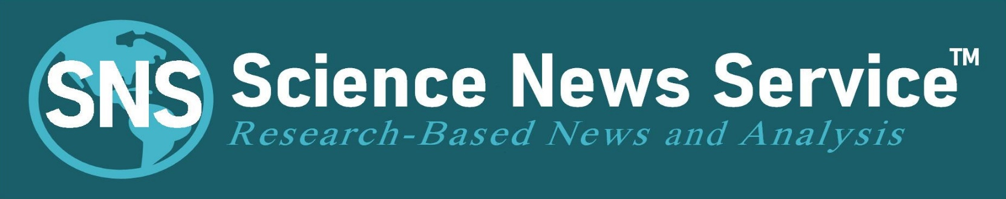

SCIENCE NEWS CONTENT
FOR IMMEDIATE RELEASE

July 3, 2020
By Rosalie Marion Bliss
MA Journalism and Public Affairs
rmarionbliss@gmail.com
239-289-5823 mobile
www.ScienceNewsService.com

HEADLINE:
The European Union Flattened the Curve
Using a Collective-Protection Strategy
The U.S. SARS-Cov-2 infection rate climbed to nearly 15 times that of the European Union (EU) per capita by the end of June. At the same time, the EU’s curve has remained flat since the end of May. The EU’s success in the fight against Covid-19 is due in part to minimum breathability and filtration requirements for public face masks that were set along with testing methods to ensure conformance.
The EU’s attitude toward wearing face masks in public is part of a “collective-protection strategy.” EU residents predominately adhere to stricter laws enforcing mask-wearing under penalty of fines. In France, for example, the penalty for not wearing a face mask on public trains is xyz.
Breathability in public face masks has become a contentious topic in the United States. Videos of concerned citizens scolding lawmakers over facemasks that potentially impair breathing have been circulating. And a budding “anti-mask” movement appears to be afoot.
Meanwhile, the U.S. public is still trying to figure out what materials to use in home-made or store-bought masks from YouTube videos and unregulated manufacturers.
the EU’s requirements that ensure public face masks meet set breathability and filtration criteria was published via open access in June.
Some put time into making home made masks, only to learn they can’t breath in them.
IFTH, the Industrial Technical Center for Textiles and Clothing, helped coordinate companies in the choice of materials necessary for producing safe, effective face masks as part of the fight against Covid-19. By early June, more than 100 French manufacturers applied to pass conformance requirement for the “Savoir Faire Ensemble” quality label.
END: To see various entries on face mask fabric combinations that passed both breathability and filtration criteria set by the EU, go to WWW.ScienceNewsService.com.

representative conformance and non-conformance face-mask combinations below.
The European Union set minimum breathability & filtering requirements for producing "consumer" face masks.
--

The EU's consumer face mask effective filtration criteria is set at a basic 70 to 90 percent. Breathability is established via tests that measures “breathing resistance” and “air permeability”, with specific limits set for both.***** 34 words

Masks Flatten the Curve
Regions where the general public wear breathable face masks that simply filter in the 70-to-90% range flatten the curve. “xxx”, said former FDA during a CNN townhoall.

Public Facemask Standards
Community face masks go thru testing before market in Europe. Balancing breathability with filtration is key to strategy *****

Europeans see wearing them as altruism toward protecting people collectively.

US struggles to figure out which materials safe for consumer masks while EU put out standards

Characterization and marketing of "general public" masks cat. 1 & 2: approach and guide - MAJ 09/06
The creation of two new categories of work equipment exclusively reserved for non-sanitary
KEY: uses intended to prevent droplet projections was officially announced on Monday, March 30. At the end of an approach supervised by the National Agency for the Safety of Medicines and Health Products (ANSM), with the support of ANSES, two new categories of masks for the general public have…

COVID-19 - Specifications and database for the production of “general public” masks -Updated 05/26/20
The Fashion and Luxury Sector Strategic Committee, the EuraMaterials and Techtera and IFTH to coordinate the mobilization of companies in the choice of materials necessary for production of masks as part of the fight against Covid-19. The CSF Mode…
Performance of textile masks: the evaluation of materials as the only guarantee
KEY: “For many of us, choosing and wearing a mask is not easy or intuitive, and the recent glut of self-proclaimed expert opinions on the effectiveness of different masks has only served to confuse the public and favor uncertainty around the quality of products available for fellow citizens,” explained the French label initiative. “During a public health crisis, people need confidence in products they make and buy.” *****
FRENCH LABEL STORY: In the new market for textile masks, while protecting people with reliable and durable products? The French fashion-textile-clothing sector has had a new tool for differentiation for a few days: voluntary certification allowing a distinctive French quality label to be affixed on a mask.
Federating an exceptional collective effort to produce textile masks, the French Fashion & Luxury Supply Chain Committee created at the beginning of April 2020 the group SAVOIR FAIRE ENSEMBLE (SFE FAIRE ENSEMBLE). The latter has recently chosen to pool the strong values ​​held by French companies to produce "Consumer Masks" through its new quality label KNOW HOW TOGETHER.
Announced in early June to the SFE group of more than 1,200 companies, more than a hundred manufacturers have already expressed their interest in affixing this label to their mask. *****
The SFE group has entrusted the voluntary certification work to the French Textile and Clothing Institute (IFTH), recognized as a competent and independent third party to control the quality of this French production of textile masks.
“A community face covering that hinders the user's ability to breathe when first put on is deemed unsuitable. The user should be aware that it can take time to become comfortable with the community face covering,” explains CEN in its reference guide.
A link to the initiative’s document referencing minimum performance requirements and testing for re-usable material-based consumer face masks intended for the general public—whether homemade or mass-produced—is freely available to interested parties and can be downloaded at: ftp://ftp.cencenelec.eu/EN/ResearchInnovation/CWA/CWA17553_2020.pdf
SEE CHART BELOW
Science News Service (SNS) offers research-based news focused on face mask quality for consumers free during the pandemic. News outlets can download content to run at ScienceNewsService.com, then click on SNS News Stories in the main menu. SNS is a non-profit dedicated to science-based journalism. See chart below. ###

For Further Reading:
AFNOR: https://www.afnor.org/sante-securite-travail/pack-reprise-dactivite/
French Directorate of General Armaments (DGA): https://www.defense.gouv.fr/english/dga
European Committee for Standardization (CEN): https://www.cencenelec.eu/covid19/Pages/default.aspx
Industrial Technical Center for Textiles and Clothing (IFTH): https://savoirfaireensemble.fr/

