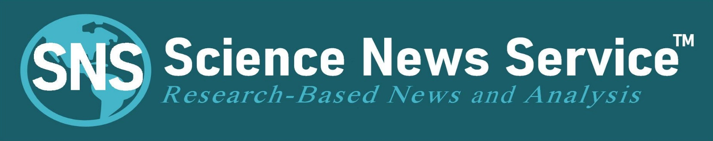

SCIENCE NEWS CONTENT
FOR IMMEDIATE RELEASE
Contact: R. Marion Bliss
MA Journalism and Public Affairs
Science Writer
Science News Service™
239-289-5823 cell
June 27, 2020
By Rosalie Marion Bliss
www.ScienceNewsService.com
Contact: rmarionbliss@gmail.com
When it Comes to Community Face Masks, Europe is Ahead of the Curve
The European Union supports consumer face-mask standardization
The European Committee for Standardization (CEN) published a free reference guide on the minimum requirements for the design, materials, and performance assessments of community face coverings intended for use by consumers. The standardization initiative was in direct response to a request from the European Commission (EC), which is the European Union’s (EU) Executive Branch and was make available June 17.
In most European countries, community masks have become fundamental to national strategies guiding the gradual lifting of stay-at-home measures in place. The EC linked coordination in consumer face-mask production for consumers as urgent to the cause of re-opening safely.
Europe’s initiative on requirements for face masks tailored for the general public is timely. U.S. Covid-19 infections, per a seven-day moving average, climbed back to its previous peak with 30,500 per day this week, while the EU’s dipped below 5,000 and has remained flat since early May. That puts the U.S. infection rate at 9 times the per capita rate of EU, according to Johns Hopkins University data.
How Did They Do That?
In March 2020, AFNOR, a voluntary-standards group based in France, mobilized a web-based “solidarity” platform to knit supply with demand for producers of face masks tailored for the general public, which are not included in the scope of personal protective equipment (PPE) and medical devices (MD) that have long been regulated. By late March, European authorities set up a new framework creating the second distinct category of face masks: “consumer-use masks,” or Category 2 masks, are separate from “professional-use masks,” or Category 1 PPE–MD masks.
The effort led to standardization activities for producing “community face masks” worn by healthy or asymptomatic members of the general public at a time when U.S. cities, counties, and local communities were scrambling to learn best methods, materials, and practices from YouTube.
The U.S. Department of Health and Human Service’s CDC asked the public’s aid in hand-crafting masks in April. Both AFNOR and CDC note that face masks intended for the public complement, not replace, social distancing and hygiene practices that are essential to fighting SARS-CoV-2. The free reference guide addresses both filtration efficiency and breathability in a way that can reduce confusion for consumers searching for criteria when getting cloth face masks intended for the public.
Wearing face masks is viewed by Europeans as altruism, because the masks are intended for participants as part of a collective-protection strategy. See the chart of representative conformance and non-conformance face-mask combinations below.
What is a consumer, or community, mask?
Basically, Europe defines consumer masks as fabric masks that are washable and reusable, designed to prevent the projection of saliva droplets and their consequences. Category 2 consumer masks have filtration properties ranging from 70% to 90% of emitted particles sized 3000 nanometers wide or greater. While SARS-CoV-2 is a mere 100 nm wide, AFNOR explains that “the virus is carried in micro-droplets sized much larger than the virus itself, so community masks offer good droplet-particle retention when worn in settings where other people also are wearing masks.”
In the U.S., results of new peer-reviewed scientific studies have been released on testing various fabric-material combinations for filtration efficiency. None or few of the studies have addressed breathability. In addition, some of the U.S. studies tested fabric combinations that filter upwards of 95% to 99% of particles sized as small as 300 nm (the requirement for U.S. N95s). Such combinations would not conform to breathability or filtration criteria set in the European authorities’ document. "The producer [of consumer face masks] shall perform verification and validation tests within its facility or in collaboration with a test laboratory that has the appropriate means of testing before placing any community face covering on the market," explains the guide.
The EC saw the need for a coordinated and consistent degree of safety in producing community face coverings at a time when duplication of effort served to fragment a single market, according to CEN’s general director Elena Santiago. CEN worked closely with AFNOR and other groups to offer the publicly available reference guide, which also documents requirements for testing the consumer face masks.
Notable highlights of the consumer mask standardization initiative include:

● Three different respiratory-resistance and air-permeability tests to help ensure wearers can breathe.
● Consideration for consumer masks to be recyclable or compostable to ensure sustainability.
● Use of fabrics that allow air to pass through when breathing, while sealed around the perimeter.
● Do not use vertical seams along the nose, mouth, and chin.
● Do not use vacuum cleaner bags, building-construction materials, diapers, or similar items.
● Do not use textiles treated with possibly harmful chemicals.
● Do not use irritating fabrics that would make community face masks difficult to wear.
● Do not use fabrics that are stiff and create gaps around the perimeter.
● Do not use highly permeable, loosely constructed fabrics.
● Include how-to-clean instructions and ensure materials withstand cleanings at 140°F or hotter.
● Beards can reduce filtration efficiency to below the limits set out in the reference guide.
● Adult face and head size dimensions are illustrated to aid achieving a proper fit.
● Children’s sizing in three age categories are illustrated to aid achieving a proper fit.
“A community face covering that hinders the user's ability to breathe when first put on is deemed unsuitable. The user should be aware that it can take time to become comfortable with the community face covering,” explains CEN in its reference guide.
A link to the initiative’s document referencing minimum performance requirements and testing for re-usable material-based consumer face masks intended for the general public—whether homemade or mass-produced—is freely available to interested parties and can be downloaded at: ftp://ftp.cencenelec.eu/EN/ResearchInnovation/CWA/CWA17553_2020.pdf
SEE CHART BELOW
Science News Service (SNS) offers research-based news focused on face mask quality for consumers free during the pandemic. News outlets can download content to run at ScienceNewsService.com, then click on SNS News Stories in the main menu. SNS is a non-profit dedicated to science-based journalism. See chart below. ###
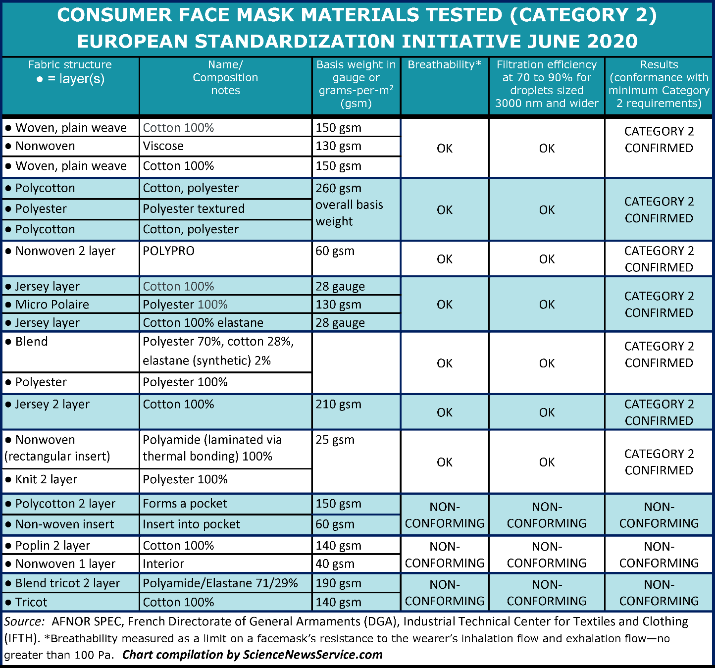
For Further Reading:
AFNOR: https://www.afnor.org/sante-securite-travail/pack-reprise-dactivite/
French Directorate of General Armaments (DGA): https://www.defense.gouv.fr/english/dga
European Committee for Standardization (CEN): https://www.cencenelec.eu/covid19/Pages/default.aspx
Industrial Technical Center for Textiles and Clothing (IFTH): https://savoirfaireensemble.fr/

